LIANZA MEMBER SURVEY FEBRUARY 2024
NUMBER RESPONSES: 101
KEY FINDINGS
- There was a high confidence rating given for LIANZA communications received over 2023 with an average rate of 8 out of 10.
- Respondents were very positive about LIANZA's current communications overall, finding them engaging, relevant, clear, and well-written and having thoughtful content.
- There are clear themes to focus on for professional development in this feedback. Some of these themes are already planned to be provided by SIGs.

Members would benefit from better communication on how people can get involved with the various communities and special interest groups.

There was overwhelming support for LIANZA-organised roadshow events in regions, with 86% in favour.
- There were a number of comments about there being too many communications channels to monitor, with a number of comments about the website(s) needing to be streamlined and refreshed and concern about the lack of use of LIANZA Connect. Te Rau Ora Library Life was favoured.
- 62% supported producing four issues of Te Rau Ora Library Life a year instead of six.
- Besides a range of suggested topics for articles, several comments were made to increase the use of video formats. This could be used for interviews with a shorter article/blog of the highlights.
- 54% of respondents had not used the LIANZA Connect platform.
- 85% of respondents said the frequency of LIANZA’s communications was about right.
- There is clear feedback that the sector feels ‘information overload’. Hence, focusing on fewer channels, more concise and considered communications. Joined-up comms across the sector may be useful to help engagement.
- 59% of respondents said they would still attend LIANZA PD events if there were a small cost for members and a larger cost for non-members. However, respondents want these to be available to everyone in the sector.

Responses suggest that LIANZA should review how LIANZA communities are supported.
- Responses were generally positive on the progress being made by LIANZA against the strategic objectives scoring an average 7 out of 10 rating on progress. This is an excellent rating when we are six months into a three-year plan.
- Members felt that they were already too busy in their day jobs to be further involved in LIANZA in a voluntary capacity. Others commented that for low-income, part-time library staff, the membership fees were too much.
RECOMMENDATIONS
- Consider the development of professional development partnership opportunities with ALIA and provide information panels/events that capture a wider paying audience. Talk to PLNZ about ‘joined-up’ offerings (several comments were made about duplication with what PLNZ are doing now they have followed LIANZA into this area).
- Provide regional roadshows to reinvigorate interest in regional areas. Look at communication channels for these communities/sigs. This fits clearly with LIANZA strategic objectives.
- Ensure that the communications are kept at a manageable frequency and that the comms are kept at their current or improve in readability.
- Work on a refreshed website that consolidates the number of platforms we use by combining the Libraries Aotearoa and www.LIANZA websites for the 2024/25 budget.
- To address information overload issues, it is recommended that LIANZA provides more ‘joined-up’ comms across the sector with other sector organisations, as this may help all of our engagement.
- Move Te Rau Ora Library Life to four times a year, trial video interviews linked into the publication and find new ways to engage special libraries. This enables the comms advisor to concentrate more on strategic comms and content development.
- Provide a webinar on LIANZA Connect so members know how to use it. Each LIANZA Council member to post one question monthly and engage with responses to get discussion across the sector. Continue to encourage the move off of libs lists into communities on Connect.
- As recommended in the report, prioritise some well-developed, paid PD options, that are manageable within the Office resources available.
- Reinstate the regular LIANZA community and sig chair meetings with LIANZA Office.
- Provide regional roadshows to reinvigorate interest in regional areas. Look at communication channels for these communities/sigs. This fits clearly with LIANZA strategic objectives.
- Review the criteria and promote the contestable fund to LIANZA regional and special interest committees.
- Acknowledge that LIANZA members are concerned about the current political environment and what it might mean for library and information services. They want LIANZA to keep advocating for the sector. This is in line with the current strategic plan.

Excel sheet: TE RAU HERENGA O AOTEAROA LIANZA - MEMBER SURVEY 2024 responses.xlsx

- FEEDBACK ON COMMUNICATIONS

- Rating scale
On a scale of 1-10, with 1 being poor and 10 being excellent, the average rating for LIANZA communications was given as 8.
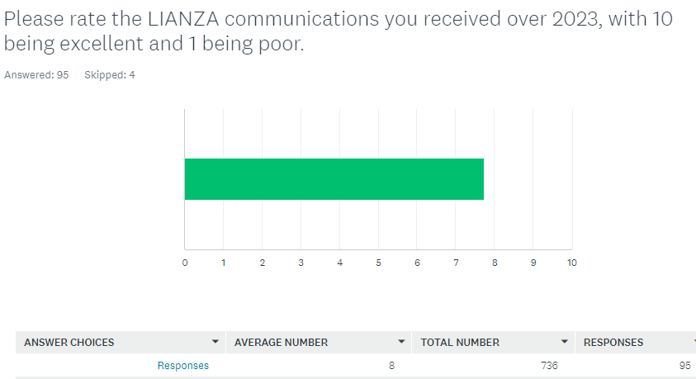

“I think the communications are good, and that they must really continue to be good into the future. I would not want to see them changed.”

- Responses to what members liked most about our communications.
Respondents were overall very positive about LIANZA's communications, finding them engaging, relevant, clear, well-written, and with thoughtful content. However, a minority of respondents still feel burdened with too many communications and others felt they were not always relevant for their sector.
- “Regularity and relevance. LIANZA office comms are always timely, friendly and professional, which I like. Articles in the publications are always really interesting.”
- “I enjoy Kōrero and Te Rau Ora Library Life, but LIANZA Connect hasn't really gelled with me. The discussion threads aren't very often aligned with my interests.”
- “Keeps me informed about professionally relevant information.”
- “Consistent branding means it's instantly recognisable. Each issue of Library Life is full of interesting news & information. It's a great example of meeting the community's needs with news, updates, interesting overseas news and sector developments.”

- Thinking about the LIANZA websites, LIANZA Connect, Kōrero and Te Rau Ora Library Life, what could be improved?

General:

There were a number of comments about there being too many channels to monitor. On the whole, people were very positive about Te Rau Ora Library Life and Kōrero, but felt that the website needs a refresh, and they were concerned about the lack of use of LIANZA Connect.

- “The website is not very exciting or calls for engaging with. Lianza Connect good, can read the content and opt to respond or not. Library Life I like.”
- “I would love people to use LIANZA Connect more regularly to have share updates, have lively discussions, etc. It's just a shame that it's so underused by the membership. I commend the LIANZA office team for trying to encourage its use, but it's just tricky to get people in there. I am really satisifed with the LIANZA website, Kōrero and Te Rau Ora.”
- “I mainly rely on email comms and rarely use the websites. One thing that I have noticed though, is that the navigation between them changes and can be confusing, bringing the sites into one should be a goal or duplicating navigation so it’s seamless.”

WEBSITE

There were a significant number of comments about the website(s) needing to be streamlined and refreshed. The Council will remember that a proposal to combine the Libraries Aotearoa and www.LIANZA websites in a refreshed website was sent to them in 2022. It was costed in 2023 but did not make it into the 2023/24 budget. This should be considered for the 2024/25 budget.

- “When I use them, can find the info I need. LIANZA website home screen not v engaging, limited options, https://www.lianza.org.nz/ compared to https://www.lianza.org.nz/about/”
- “There isn't a lot of info on the LIANZA website. Trying to find Regional Council info is difficult. It is the regions that most members will be dealing with if they want to get involved or make contact. I often think I will look for info on the LIANZA website, but then see content is added to this one which is a bit confusing https://www.librariesaotearoa.org.nz/”
- “I am not a massive fan of the website. It's OK, but some things are buried down a couple of layers e.g. upcoming SIG events.”
- “*Improved navigation on the website eg It's not obvious from the front page on how to find resources.”
- “A more user accessible website”.

LIANZA CONNECT
54% of respondents had not used LIANZA Connect.
- I'm not sure that LiANZA Connect is taking off as much as expected. It's a good place for sharing news and links and announcements, but it doesn't feel like a place for discussion.
- I'm unsure of the point of LIANZA Connect.
- Connect isn’t really utilised.
- Would like to see more activity on LIANZA connect. I think council could be doing more to model use there.
- I guess it's a bit message-board-y, like it could be more chat like?

Suggestions for improving LIANZA Connect include:
- Encourage more public library/council engagement.
- Repeating how to use it and set up a webinar on how it is used.
- Setting up all LIANZA community and special interest groups on their own communities.
- Raise controversial questions to get korero going.
- More straight forward access and sign-ins.
- Kill off NZ Libs.
- Get some "influencers" onto the platform for special conversations e.g. for open access week ask all the University Librarians to come onto the platform to answer some tricky questions.

- A mechanism like LIANZA Connect was considered about 10 years ago, and we didn't do it then primarily because there are already so many other channels (NZ-Libs, PLNZ lists, specialist list services). I think driving engagement in yet one more channel is an uphill battle.
- One thought I had was to host webinars/workshop/discussions in an online meeting space and put people in groups to discuss issues pertinent to the sector. Then encourage them to share their thoughts on LIANZA Connect as a follow up. We know librarians and information professionals are bright, well informed and passionate people, so it would be great to have us all engaging with one another more deeply in an online space.
- My work is so specialised that I use my networks to answer any of my questions tbh. There are so many platforms that I sort of stick to existing structures like NZ Libs.

TE RAU ORA LIBRARY LIFE
The general feedback on Te Rau Ora Library Life was very good. But shorter, more bite-size blog options were suggested.
- I love Library Life - it's visually appealing and always has something of interest a wide range of people.
- It's a great way to catch-up with what's happening in libraries. We print it and leave it in the staffroom so it's accessible to all library staff.
- I would prefer less to read through or possibly shorter, sharper pieces that I can skim easily. I often don't have time to read everything in my inbox. I find the website useful for general information. I wonder if Library Life could be integrated as a blog on the site (rather than a separate magazine format). Then I could subscribe to the blog and receive updates when there are new posts.

Respondents were asked if the publication should be produced four times a year not six times. 62% said four times a year was sufficient. With an updated blog site on a refreshed website, the publication of Te Rau Ora Library Life may be altered to be real-time blog news.
There were concerns about articles and publications being relevant or becoming dated if they were only four times a year. This could be addressed by greater use of a blog on a refreshed website.
- If getting material or staff time is a problem and therefore 4x per year is more practical, then go for it. I personally like that Library Life has current material and getting info that is up to 3 months old makes me wonder if LL could eventually end up as online articles only, published when they're ready instead of as a pdf publication. (I do like the pdf format though but would be more inclined to use the Lianza website if LL was produced in such a way).
- I think 4 times might 'slow the flow' a bit and maybe date some content a little. Could be shorter, if getting content is difficult.
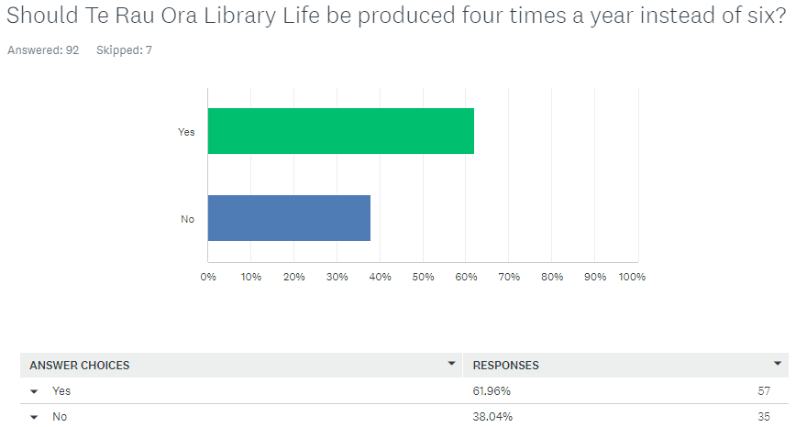

- THE FREQUENCY OF LIANZA COMMUNICATIONS
Respondents felt the frequency of LIANZA’s communications was about right. But there were many comments about the number of emails people receive every day. Caution about posting should be considered and a strategy of more sector-aligned comms should be the aim.

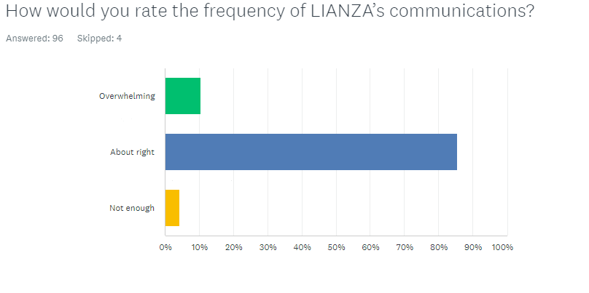

WHAT AREAS SHOULD LIANZA BE EXPLORING (ARTICLES, FORMATS, EVENTS ETC)?

The following list gives some idea of the type of articles or webinars that could be provided by LIANZA. It indicates that using video more in our communications would be useful. Some interviews for Te Rau Ora Library Life could be trialled on video.
- Support and advocacy tools for library challenges
- More on local government and managing budgets
- Te Tiriti, WAI262, indigenous data sovereignty and advocating for a collective digital Preservation strategy
- More resources for those who are new to librarianship or are wanting to start learning about cataloguing, digital collections, or other SIG related or specialist areas of knowledge
- Public libraries
- International and regional library news
- Emerging technologies in library and information science, articles, videos and interviews exploring new technologies such as artificial intelligence, blockchain, virtual reality and their implications for library services.
- Examples of partnerships that demonstrate a Te Tiriti o Waitangi approach.
- Copyright, AI, vocational education & tertiary sector.
- Profiles of people with everyday library jobs.
- How cost-cutting measures from the government are playing out in libraries. interviews with the politicians who are proposing the cuts etc.
- More on trends, sustainability, and budgeting constraints (making the budget work as hard as possible).
- Special libraries, collection management.
- I think you have a good balance and would like to see more webinar discussions perhaps of relevance considering the briefing you gave to Ministers and impacts on future.
- It would be great to see more about tertiary libraries and special libraries. It sometimes feels like those two library sectors are forgotten about. Generative AI is a huge issue for tertiary libraries in 2024 so it would be good for LIANZA to raise discussion and facilitate sharing on this topic. How about having a 'I attended this webinar/conference, and here's what I learned' regular post, written by a range of librarians?
- Public Library - Connecting with writers and publishers so aware of their issues. More about Pleasure of Reading and place books play. Plus more on the research being done around Pleasure of Reading - and role libraries play in making that happen.
- Data-driven, analytical, best practice. But it's difficult to get those things when everyone is so busy already
- I would like to see more discussions, articles and interviews around pay
- Videos
- maybe article highlighting how people are using their library / info skills in non traditional ways?
- More videos would be brilliant. Just because they're engaging and the way that many people are choosing to engage with online content and get informed.
- I'd prefer less channels and more focus on current and relevant topics. Guides on providing advice on e.g., copyright, Chat GPT, AI, etc.
- More articles - possibly on the tertiary sector? There are many challenges currently facing this sector, and also many exciting developments too. As to additional formats - I think we can reach format variety overload!
- Posts - break down/draw out key and interesting copy and post of social media - social media is not strong, timely or share live areas of interest. ie was anyone at the Kingi Tuhetia's hui a motu? 10,000 people were there about the nations basic founding documents.
- A series of video interviews with people in the sector would be cool.
- Maybe issues could be dedicated to specific subjects - cataloguing; children's & teens; older persons (including emerging dementia collections); acquisitions; etc.
- I prefer short webinars/blog posts which I can watch/attend over 30 minutes is enough. An hour is a long time if it's during your working day (or after hours). I would love to see an area where people can share their graphic and design work for others to use freely https://librariandesignshare.org/ This is really useful for ideas and inspiration and avoids reinventing the wheel. I would also like to see less text heavy articles and more visual sharing with a Padlet of library displays/spaces/signage etc. Library people are often looking for quick, sharp inspiration and images are a great way to do this.
- I think it is a shame that we no longer have a scholarly journal for NZ professional librarians.
- Maybe some nation-wide panel discussions about ethical/contentious issues. So members can learn from expert discussions and have the chance to ask questions & share in the debates.
- LIke to see you chasing and encouraging more special library participation. I'd like to see more engagement with the sigs, as they lost a lot of their ability to do magic when their budgets were stripped away. LIANZA needs to develop a strategy around all library types and find ways to get these other library types out there.
Webinars that could be considered are:
- Webinar series for those new to the sector on copyright, cataloguing, digital collections, and more
- For next-level management library staff: working in local government, budgeting, sustainability and managing challenges to libraries such as budget cuts.
- Understanding Te Tiriti o Waitangi and WAI 262 implications for library and information services. Partnership examples.
- Emerging technologies in library and information science, including AI, tertiary libraries and generative AI
- Interviews or panel discussions with experts on ethical and topical issues and views on government impacts and future/role of libraries.

In addition:
- Pleasure of reading columns in Te Rau Ora, input from publishers and writers.
- More video interviews.
- Guides on providing advice on areas such as copyright, Chat GPT, AI,
- There was clear feedback to increase the content on special libraries.

2. PROFESSIONAL DEVELOPMENT/WEBINARS
I think the Professional Development opportunities are fantastic and more of those would be amazing, though at the moment they are fine as they are.

Respondents want everyone in the sector to be able to access LIANZA webinars and professional development. There was an acknowledgement that many had their LIANZA fees paid by their employer, but other new professionals, who often needed the training, didn’t. Others felt that there should be some benefits to being a LIANZA member. 59% of respondents said they would still attend the events if there was a small cost for members and a larger cost for non-members.
Comments in this section would suggest a move to charge non-members for some of our professional development/webinars. This area is a key member benefit and clearly fits within the strategic plan: to support and empower library and information professionals in their career development.
In 2023, there was one paid PD event with Mary Ellen Bates where 96 people registered for the event, and a rating scale was provided, with personal members paying the least.
Networks, SIG and LIANZA promotional events should not be charged as they are already reliant on members running them or are a channel for us to inform members, for example the professional registration scheme. However, the development of information panel events or exploring professional development partnership opportunities could be investigated. Co-ordinating, planning and running these events takes significant staff resources.
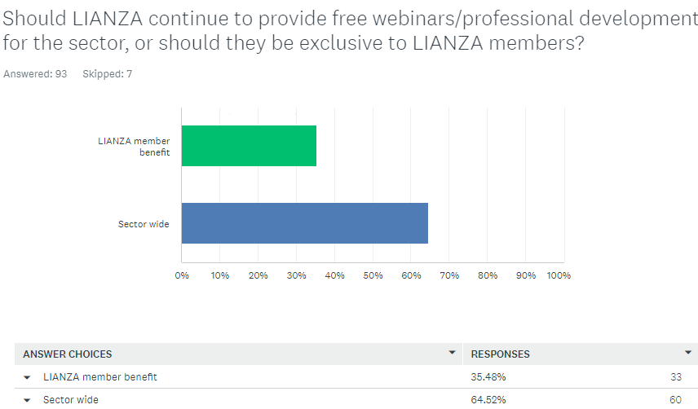

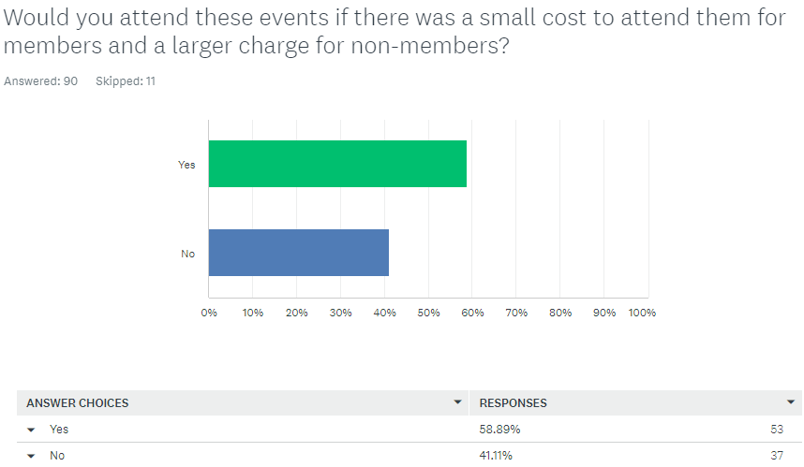

- My employer pays my institution and individual LIANZA fee. I usually don't need the training, but my Library Assistants do. Good for Council to see a benefit for money it pays.
- There is very little benefit to being a LIANZA member. It doesn't increase my pay rate, there is no professional negotiation with my organisation on my behalf, non-qualified people are appointed to qualified roles, and LIANZA doesn't really make a case to organisations why qualifications matter. At least free professional development should be limited to those who bother to be LIANZA members. If there is a charge open it up but ensure that the cost for LIANZA members is much less.
- I think we need as much engagement as possible in this sector. Excluding non-members reduces the likelihood they'll see the organisation's value because they won't be participating in it or seeing the range of what Lianza does. I personally don't care that they may benefit from what's provided by member's contributions (including my own). I'd rather they get the opportunity to grow and learn in our profession.I think we're too small a sector for us to be a member's-only club.
- It is probably not sustainable to provide them free for everyone and we want to encourage more people to join as members. So I think that ideally they would be free for members with a charge for non-members.

What webinars or professional development would you like to see LIANZA provide next year?
Several comments were made that these should be done alongside the tertiary providers. AI and new technologies were the most often mentioned. The general themes fell under:
- More focus on new and evolving digital technologies, digital search strategies, AI especially, but based on how it will impact. Generative AI in tertiary settings.
- Creative tech in libraries - what are the service models and how are they working? What does the 2030 library look like? Library trends and emerging practices from overseas - can we, should we apply them to New Zealand? Webinars/PD on 'conquering the scammers' and showing your patrons how to do it. Vendor show cases - get EBSCO to deliver what's comign up type things.
- Information literacy/disinformation/literacies overall including health and digital. How to tell the difference - critical thinking skills and how to teach these to the public, what to do when challenged with it.
- Challenged materials in collections - strategies for dealing with complaints during these times of increased 'book banning'
- Climate change and how libraries and librarians are involved. Sustainable communities. Advocating for SDG's
- How to develop strategic partnerships, relationship management, community development and engagement and seeking funding.
- More of that next level management specific info, managing budgets, LTP and annual plan processes for local government - Navigating restructures and advocating dynamically with Councillors .
- Mātauranga Māori content,Wai262, digital only collections, Te Tiriti and how we can be better citizens. Te reo Māori conversation/practise groups? Te Reo use in libraries. Whakapapa & Māori resources.Indigenisation/decolonisation of libraries. Te Ao Māori and also Pacific cultures.
- Research and Innovation. Ways to research and make decisions around contentious issues, and how to advocate for library services in the particular NZ environment.
- Copyright – plus electronic resources and copyright
- Focus on reading - information about what children are reading, popular trends in reading, virtual tours of other libraries, Display ideas/book promotion Readers’ advisory for tweens.
A session to hear from the Deakin University team who have been running a project "Discovering a 'Good Read': Cultural Pathways to Reading for Australian Teens in a Digital Age" They are publishing their final report from this project https://teenreading.net/
- Creating successful programmes, increasing staff engagement and public libraries - dealing with differing opinions in communities. Dealing with stressed clients. Discussion about customer behaviour in public libraries, maybe some different libraries in different parts of the country
- How libraries run their: youth clubs/after-school clubs/groups, Outreach to the wider community all ages, 0-17+ ➢ Te Reo , Holiday programmes/summer reading challenge. Engaging with recent refugee groups settling into our communities. Good customer service, coping with coming tech changes (e.g. AI) and how they will impact library services.
- Engaging your users - strategies for communication, getting them in the door/portal, and keeping them interested.
- Continue the dementia collection conversations and services to special needs groups in general. More on neurodiversity.
- Cataloguing 101: (2023 cataloguing webinars were popular), more on subject cataloguing, especially the Maaori Subject Cataloguing would be great. Aspects like weeding, digital repositories, subscription management. The RDA and its practical use.
- Late last year Australian Law Librarians Association ALLA ran a session open to all "Service as leadership: Reaching for sustainability at work (ALLA Vic Mental Health Series)" - it was great (can supply more details.
- Opportunities to hear from LIANZA members about their leadership journeys. career advice - what do people do when there is nowhere within the organisation to move to and you can't leave your town - keeping your job interest alive.
- How the sector can strengthen our ability to showcase our value and become dogged advocates for our services, collections and people. Marketing our libraries.
Other - Collaborating with library associations or professionals from other countries to share insights and exchange ideas. Analytics and stats collection. Revalidation of Professional registration, applying to be an associate. Research or local/family history/whakapapa stories.
Recommendation:
There are clear themes to focus on for professional development in this feedback. Some of these are themes that are already planned to be provided by SIGs – such as climate action and challenged materials mis/dis information. Prioritising some well-developed, paid PD options, that are manageable within the Office resources available, are recommended. Some of these may be done in partnership with other organisations eg ALIA and PLNZ.
- Continue the child and youth network as it has high engagement (not paid PD). This also addresses some of the programming areas mentioned.
- Support the LIANZA cataloguing community professional development webinars
- Webinar series 1 - What does the library of the future look like – a look at new technologies, library trends and emerging practices. A particular focus on AI (paid PD or sponsored)
- Webinar series 2 - Supporting Mātauranga Māori and Te Tiriti o Waitangi in our library and information services. This could be a series looking at examples of partnership, what Te Tiriti says, Wai 262 and more. It may develop into a Te reo Māori/Tikanga practice session. (paid PD or sponsored)
- Showcasing the value of your library – as part of the comms strategy on the value of libraries. How to market your library, data pictures and more (PLNZ)
Some potential one -offs (with PLNZ?) – there may be others that could be explored
- Next level management, budgets and strategic planning
- Managing differing opinions and difficult library users, what are the behaviours acceptable in a public library.

HOW CAN LIANZA BETTER SUPPORT REGIONAL AND SPECIAL INTEREST COMMUNITIES?

Responses were vague to this question with many unsure how to respond.

Members would benefit from better communication on how people can get involved with the various communities and special interest groups. A discussion with these member groups on the communications platforms available to them through LIANZA may also support engagement.

Consideration should be given as to how these communities can be supported by LIANZA. There has been no LIANZA community hui since the first one in 2022 and the regular bi-monthly meetings with LIANZA Office have not occurred for the last year.

Provide mechanisms to support their work, advocacy for these communities.

Encourage them to communicate more. I don't think a lot of people know where to find info on the communities. It is very tricky. There are old blogs around and twitter accounts that haven't been updated in years.

Basic leadership/management skills for committee leaders, maybe

My regional community is dead. There are no LIANZA events here. Or the one event that was held was of no relevance to me.

It seems each of the LIANZA groups are often seeking members. Sell the benefits more. The Professional Registration Scheme is still good and should be maintained.

Unsure, but support is important. I am a member of ResearchSIG committee, and we found the support for our 2022 research symposium (which we shared with TELSIG), to be invaluable to our efforts.

Funding for professional development opportunities. Bringing together the committee members in forums to discuss their challenges in engaging members and discuss opportunities to collaborate together.

Challenging given the sheer size and distributed nature of members across the communities. Maybe mentoring or budding of new members to encourage attendance/participation.

Continue to provide administrative and financial support.

In recent years representatives of these communities have met via Zoom on a regular basis to exchange ideas and support. This certainly connects the convenors with the LIANZA executive manager on a regular basis, other than by email.

There were a number of comments about access to budgets to run events. The contestable fund available to these groups is either not known of or the criteria is too limited.

Allow regions to retain some of the/local membership' fees for hosting local events which can bring members together.

Giving some autonomy back to SIGs with their budgets for running events would be a start. Or at least more consultation/conversation around the funding of events. The change a few years back was very disempowering. SIG committee members have at times felt like unpaid volunteers being looked down upon/bossed around by the (now departed) LIANZA CEO.

We need more members on the community committees. It's difficult to fund sessions. I would go back to giving the communities the money that is paid to belong to the SIG. I have noticed that they are not thriving as well as they used to or providing the type of professional development they used to do.

I have heard that the regional communities get no money from LIANZA. Our regional community wants to hold eventsand talks but can't do this very well without a budget.

Recommendation: Reinstate the regular LIANZA community and sig chair meetings with LIANZA Office. Consider the road show suggestion for reinvigorating interest in regional areas. Look at communication channels. Review the criteria and promote the contestable fund to LIANZA and regional special interest committees.

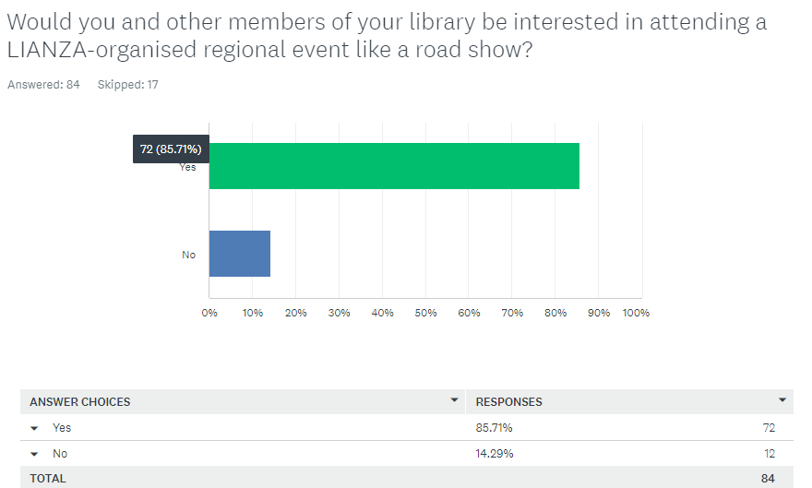

There was overwhelming support for LIANZA-organised roadshow events in regions, with 86% in favour. This will help reinvigorate local communities.

Respondents provided these ideas for the roadshow agenda:

- Showcasing regional best practice and sector innovation, networking, learning and development opportunities
- Thought leadership, practical tools and knowledge sharing
- Provide a networking opportunity
- Running digital sessions, play in libraries
- Colleagues (non-managerial) talking about the challenges we face in our work.
- How LIANZA can actually help you in your librarianship career
- Dealing with difficult scenarios
- Useful technology solutions that are helpful in libraries (for all sectors) Understanding systems and technologies
- The importance of AI in the library sector and pros and cons.

- Possibly a workshop format that enables participants to understand LIANZA's role and provides an opportunity for all participants to collaborate on the revision or development of programmes/services.
- A variety of items that are of interest to specialist libraries, not just public library focused. Maybe - it would depend on the timing and the content. For tertiary librarians, it would need to be outside the peak periods of mid-Feb to mid-Mar and mid-Jul to mid-Aug.
- What LIANZA is - does - could be, some fun/food/fellowship Opportunities for prof development and support. Nothing boring. Highlighting what the national organisation achieves - on behalf of us all. Making the point it is not all about "them and us". In some areas of Murihiku, there is a real disconnect between the local and the national. This is sometimes down to Library Managers being appointed from other sectors, who come on board, and have little or no appreciation of what LIANZA is all about. Their negative attitudes then rub off on their staff, and before we know it, we have great black holes across the region, of non involvement / no support.
- Topical areas (implications of the new coalition government, climate change future proofing, getting your library to carbon zero). Brainstorming ideas for common issues around the topics above (e.g. how do you sustainably dispose of surplus books you can't sell?)
- Dealing with management of public library and public service sectors (GLAM in general) in the new climate of Government wanting to reduce spending on public services.
- State of the sector / opportunities and threats / AI / regional communities and SIGs
- Things that are impacting libraries e.g. ChatGPT, AI, etc
- Senior leadership talking about their career journey (ideally involving LIANZA roles) so others can see their potential.
- TED type lightening talks
- Have an element of an unconference where people can contribute topics (before the day) so there is time allocated for them to discuss these and gain other perspectives/ideas/strategies. Equally this needs to be balanced by having some clear takeaways for people attending e.g. learning about new digital tools they can use day to day, hearing from a panel of local library people sharing 'lessons learned' 'current issues' 'professional tips' 'what's happening in their spaces'. What is 'top of mind' for people and what challenges are they facing? - this is often where people want input,ideas and inspiration to help them deal with their issues/challenges. Also it's always good to have an inspirational speaker from outside library and information circles to kickstart things and give people a fresh perspective e.g. Anne Milne talking about white spaces https://www.annmilne.co.nz/
- Whakapapa & Māori resources

STRATEGIC PLAN AND ENGAGEMENT IN LIANZA VISION

What would help encourage more library professionals become engaged in the work of LIANZA to achieve the goal of a thriving library and information sector?

The most repeated comments were that people were already too busy in their day jobs to be further involved in LIANZA in a voluntary capacity. Others commented that for low-income, part-time library staff, the membership fees were too much. Others said that LIANZA needs to be better at promoting the profession and the value and impact of library and information services.

These responses show the full range of feedback type:
LIANZA needs to be more visible across the sector and provide a stronger value-added proposition for its members and the profession. It needs to have a louder voice in central and local government so the profession feels supported and heard by decision-makers. I think LIANZA needs to better promote the profession and its values and impact. A lot of deprofessionalisation is happening in the sector and we need to be able to demonstrate why the profession is more important than ever and support members to rise to the challenge and stand proud of their profession and encourage qualification and professional development. I think supporting more sharing of ideas across library sectors would also help us to stand as a more united as a profession.
Encouraging employers (i.e. local government) to include LIANZA membership as part of employment packages. It is really hard to get involved when your role is "customer service specialist" despite your job description and duties being those of a librarian (done to save $$$). There is often active discouragement from even calling yourself a librarian, which does not inspire much drive to be involved in making the library and information sector thrive.
Start up-stream by ensuring that people recruited into the sector are dynamic, outward-looking, people-focused, multi-lingual/multi-cultural, ambitious, and from a wide range of backgrounds.
Help librarians in achieving their goals such as qualification, education, training and they will help you by supporting in the work of LIANZA
More relevant content for the tertiary library sector
The "professional registration" scheme needs to require a standard qualification, and not just any old qualification and some experience. I can't think of any other professional group which allows registration to be extended to people without a standard, professional-focused qualification. Teachers, lawyers, accountants, nurses etc - they all require a standardised qualification which meets core requirements.
By having more obvious benefits for all librarians and library sectors. Better advocacy - individual libraries are mainly left to themselves when going through major changes & challenges (space being taken away, lack of funding, lack of recognition etc)
More local events and communication.
Professional development scheme similar to ALIA's
A lower entry fee, a lot of library and information sector staff aren't on very high wages (or part time) so often see the membership fee as too much.
I believe that change in mindset is needed, as they need to be aware that the organisation is only as good as its members. Members change in mindset to make sure they are aware that they need to participate to get success and flow from this organisation.
How about electronic badges that people can add to their signatures for community involvement? 4) Paying people to do it?
I really don't know. Everyone seems so stressed and busy with their own jobs and organisational issues. Engaging in LIANZA work would be yet another obligation/stressor for which they have no energy.
I'm not professionally registered (lots of experience, & now library/ adjacent work) but would be happy to mentor - seems no pathway for that?
Offer members a discount on Professional Development opportunities that are legitimately recognized professional accredited courses through Victoria University. Most of us would love to get Professional PD through Vic, but are unable to afford the costs to do them or even come down to do them in Wellington. The best way forward would be to offer discounts to LIANZA members on the online Information Science courses that Vic offers and then offer them to LIANZA members.
Continue to bring people together wherever possible. There's something electric about the LIANZA conferences, people feel engaged and inspired, and then we all go back to our places of work and get busy. Trying to replicate some of that would be awesome. I really enjoyed attending one of the strategy sessions at the end of 2022 in Tāmaki Makaurau - it was great to touch base with other librarians and get talking about the key issues facing the sector.
Finding topics that people are passionate about (e.g. the recent addition of a Climate Change group) to attract people who are on the periphery of LIANZA.
I'm not registered but maybe a requirement of being registered is that you contribute to LIANZA / one of the communities in some way.
Sometimes the commitment during work hours can be tricky to negotiate with employers, so having options for those who want to participate but don't have employer support. This might mean recording meetings, or having tasks outside of work hours for committee members to do.
More awareness and getting managers etc on board as advocates as well - and not all of them are library professionals.
I think the traditional way we have operated in our communities, with committees organising events etc. - have had their day. New models of operating need to be engaged with - ones that appeal to library professionals of the 2020s.
What makes LIANZA different than any other library professional association? We are in Aoteroa New Zealand. What does this mean for the profession?
I'm not sure what LIANZA can do, as it can only work with membership fees, but so many places are not paying them for their staff and the membership or registration is no longer valued by many employers. Maybe more networking-type things within specific sectors rather than just webinars on specific aspects of librarianship.
Communicating the benefits to their organisations and their own development
This is a hard one. Most of the librarians I know are so busy they don't really have time for anything extra.
I think it is support from our organisations that often hold us back. That comes down to (non-library) managers being willing to agree to committing time. That can sometimes come back to how prepared people are to do some of this work in their personal time. If we are not interested in our own careers and professional development, then why do we expect others to? We have to be a bit self-driven.
Making people feel part of a profession, seeing value in joining (and paying for membership!). However we do have a lot of staff who work in a library, rather than necessarily seeing themselves as LIS professionals.
Maybe provide more social interaction as a way to attract more people to the work of LIANZA? I'd also be keen for a complete overhaul of the registration scheme. People have left it in droves (myself included) because they just found it too much work, and if that's a person's only real interaction with LIANZA then it just leaves people with a bad impression.
Challenge is library professionals seeing the relevance of LIANZA to their current position and practice. Inclusion of a range of 'member voice' in communications/publications is helping with this.
A young dynamic forward-thinking ambassador - a similar role to Marion Read in LGNZ but travelling to extol the value of LIANZA
I don’t know, how about targeting the non-library information professionals of which there are heaps.
Ask those who aren't members or coming along to events etc. What is their current focus? What do they want to know more about? What do they wish they'd known when they started?
Not sure as working in the Government sector, there is anxiety about public sector cuts and often libraries face ongoing challenges with the physical space and budgets. So possibly more focused on what is happening to us as individuals rather than the wider LIANZA organisation.
I think we need to start thinking about what we mean by library professionals because so much of our sector is changing. Where we traditionally had Library Assistants, we now have service assistants wearing multiple hats. A number of people are being recruited into the sector because of IT, cultural capabilities, or customer service capabilities. They do not have library qualifications; they do not work in positions with the work library or librarian in them. Not all these people have a professional identity as a librarian and so they may not see LIANZA as a relevant space for them.
If their management were onboard and promoted these events more and allowed staff to attend.
Look to the wide program-based approaches of other associations. Also look into a National Services Te Paerangi type model.

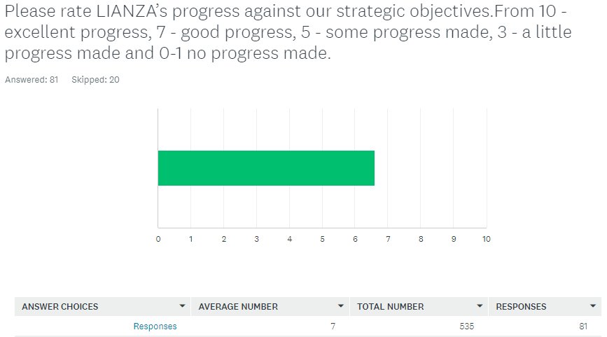

Please explain why you gave that rating and what could be done to improve that rating.

Responses were generally positive on the progress being made by LIANZA against the strategic objectives scoring an average 7 out of 10 rating on progress. This is an excellent rating for the beginning of the strategic planning period.
However, some respondents didn’t know enough about the strategic plan or LIANZA to make a rating. Those respondents who did comment are clearly concerned about the current political environment and what it might mean for library and information services. They want an opportunity to know more, to discuss the environment they are in, and for LIANZA to keep advocating for the sector. Respondents noted the work LIANZA is already doing in advocacy, Te Totara workforce capability and tertiary grants.
Responses were in the following vein:

LIANZA has made some progress with the 2 objectives "To support and empower library and information professionals in their career development" and "To facilitate an engaged and connected community of library and information professionals" negligible progress against the remaining objective. I would like to see LIANZA more visble and vocal with central and local government and working to strengthen cross sector partnerships.
I think there's more that can be done in the professional development space.
I think you do very well for small organisations with your funding.
The way I can see it over the years, being a member of LIANZA. The organisation has a strong driving force to advocate all the important issues of the library sector,
I think library and professional development is worrying and there should be more input into courses for library and information studies. As a manager, I struggle to get candidates with good digital and systems skills and also good cataloguing skills.
I think that LIANZA is doing a good job progressing this work. I am, however, worried about the future of libraries in the current political environment.
It has only been a few years since refresh and with change in government, impact upon the library sector is quite varied pending on where you are in local government, private sector etc.
Standout achievements have been Te Totara capability framework and tertiary study grants
I can't give a rating because I don't know what the progress is but I trust that all's going well.
Looking at the Strategic Objectives, I think you're actually doing a pretty good job. Just don't forget the tertiary and special libraries though.
Don't think as much support at a local level from central organisation as could be - too Wellington and North Island centric, and yet objective is for all levels of LIANZA org, including volunteers
Everyone has strategic objectives - they are just (well-intentioned) words on a page. I think the library sector is struggling at the moment, committees are struggling to attract new members. Perhaps the new CEO needs to reach out to the different SIGs and regional committees and have some conversations.
It's hard to say what progress has been made. Unless you're close to Council, it's not very visible to the general membership. E.g., have we reduced duplication? Hard to know!
It is a fine strategy, but does take incredible energy and drive to achieve. The new government is displaying push back too, so an even more challenging environment to be working in, than a year ago!
I think the association needs to be more targeted and prioritise its activity. The membership is not huge nor is the office but the strategic objectives are huge!
I'd like to see more done with embedding treaty principles in libraries.
I'd be keen for LIANZA to have a higher public profile, and for the profession to be more engaged and connected. I realise these are big tasks though.
Reading this survey, I realise I simply don't know enough about LIANZA: their initiatives and ambitions.
The conference was great, but there is more to be done. I feel like we are doing a lot to maintain the status quo. Where is the move forward to the libraries of the future?
I see a more focused and engaged approach which is a real step in achieving positive outcomes
I think LIANZA is doing the best it can. The rating encompasses the more demands on library staff in the age of redundancies, libraries becoming the place to print all of the government forms (I had to find important Immigration forms to print out for a customer whose first language wasn't English) this creates a great deal of pressure as I am not versed on what essential immigration forms are needed. I was surprised the customer had not even been emailed these.

Recommendation: consider the responses to this section and continue to be strategically focused.

